|  |  |
| --- | --- |
|  | **Title of the Lesson:**  **Cohort:**  **Dates:**  **Theme:**  **Week:**  **Learning Goals:**  **Example: ( B.1.d.)** Engages in positive relationships and interactions with adults |

**Fill in your group ____________Cohort**

**Remote Lesson Plan Grid (English)**

|  |  |
| --- | --- |
| **Title of the Lesson:**  **Theme:**  **Week:**  **Learning Outcomes:**  Can be found next to the introduction of the weeks. The sentence begins with…*This week children will explore… usually next to UNITE.* | See the source imageSee the source image**Cohort**  **Lesson Designers**  **1.**  **2.**  **3.**  **4.**  **5.**  **6.**  **7.**  **Cohorts YouTube Video in English and Spanish** |
| **Wonderful Words of the Week:** | |
| **Opening Song**  **Use Your Classroom Mascot!** | **Materials inside your Materials Box** |
| **Procedures** | |
| **Product Outcome:**  **(Pictures)** | |
| **Questions to ask Before, During and After Your Lesson**  **Use your Classroom Mascot!**  **Before:**  **During:**  **After:** | |
| **Parent Tips on Milestones/Adaptations** | **Song/s related to the Theme** |
| **Closing Song**  **Use your C**lassroom **Mascot!!** |
| **Remote Lesson Reflections** | |

**EHS Remote Implementation FLEX Lesson Plan**

**Video Overview**

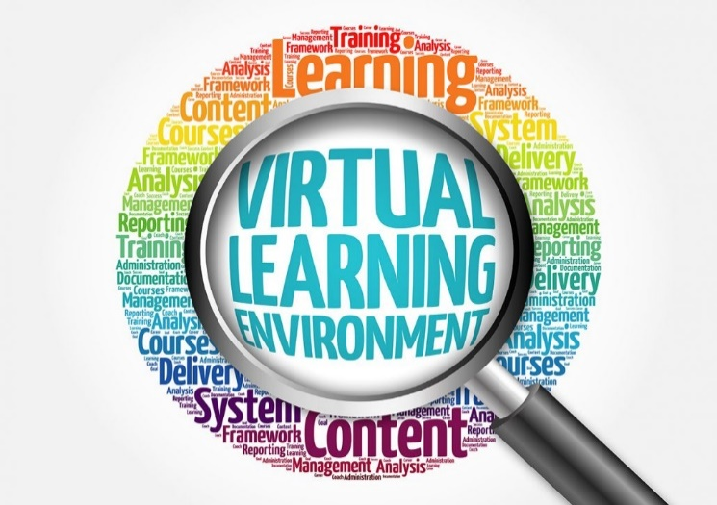

**Follow the Lesson Plan**

**Be sure to have your *Written Lesson Plan*  with you to help you prepare your lesson delivery.**

**Professional Attire**

Wear your EHS School Shirt. Look and be your best when you are remotely visiting with your children and videoing your lesson. You are a role model!!

**Follow the Video Rubric**

Have the rubric in front of you in order to follow the steps as you video your lesson.

*Example:* Opening/Closing Song, the purpose of your visit and objective. Use the lesson plan as your checklist, before and after the recording.

**Upload Your Video to A Platform of Your Choice**

YouTube or One Drive? Forward your video and remember to send the final copy to the UTRGV OneDrive.

**Thank You for moving mountains to teach our EHS children and families from a distance.**

Teacher Notes

___________________________________________________________________________________________________________________________________________________________________________